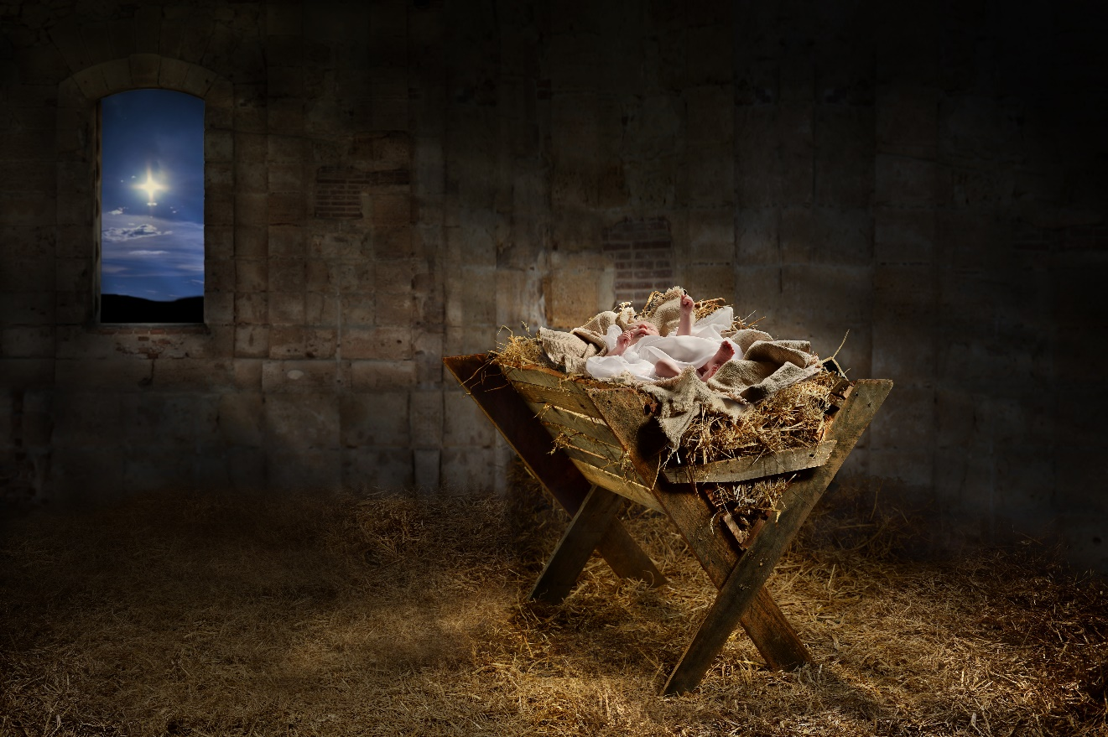

Windows on Christmas
2021 Advent Worship Series

Inspired by
Windows on Christmas by Bill Crowder

Collaboratively produced by
Corps and Community Mission Department
and Music and Creative Arts Ministries

Editor/Project Manager
Mark Bender

Worship Outlines
Peggy Thomas

Sermon Outlines
Captains Catherine and Peter Mount

Dramas
Martyn Scott Thomas

Children’s Moments
Katie Laidlaw

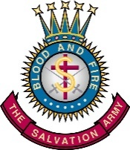
The Salvation Army | USA Central Territory
Commissioner Brad Bailey, Territorial Commander
Unless otherwise noted, this series is © Copyright 2021, The Salvation Army, Hoffman Estates, Illinois.
Windows on Christmas
2021 Advent Worship Series
FOREWORD

“Windows on Christmas” provides a fresh perspective on the Christmas story looking through the “windows” of some of the people who were there, helping us to see what they saw and feel what they felt—that we might be able to learn what they learned.

The five-week series includes worship service materials for the four Sundays of Advent, Christmas Eve Service and Sunday after Christmas. Available in English and Spanish, the series includes music options, dramas, readings, videos and other Christmas resources.

This series is inspired by Windows on Christmas by Bill Crowder (Discovery House, 2007).

The worship resources are available on the Music and Creative Arts website: https://www.samusiccentral.org/advent-2021

Video components are available on the Visual Communications website: http://wsvr.viscomapps.com/

Weekly themes for the series are as follows:

Week One (November 28, 2021): The Window of Exaltation – The Angels
Week Two (December 5, 2021): The Window of Wonder – Mary
Week Three (December 12, 2021): The Window of Obedience – Joseph
Week Four (December 19, 2021): The Window of Worship – The Shepherds
Christmas Eve (December 24, 2021): Our Window on Christmas
Week Five (December 26, 2021): The Window of Witness – Anna

Services contain:
- Song Options
- Calls to Worship/Scripture/Responsive Readings
- Advent Wreath Readings
- Dramas/Children’s Moments
- Sample Sermon Outlines

Each worship outline contains all elements needed for your worship service. The order of each service presented is only a suggestion. No doubt changes will be needed to accommodate the flow and worship style of your corps. The meeting outlines are flexible and allow opportunities to “cut and paste” as needed. If you are blessed with instrumental or vocal music resources, you may find there is more structured material here than needed. It is recommended that the headings of each section of the service be included in the bulletin.

APPRECIATION

In producing this series, the Corps and Community Mission Department expresses its indebtedness to Peggy Thomas and Katie Laidlaw (Norridge Citadel, Illinois), Martyn Thomas (THQ, Music and Creative Arts Ministries), and Mark Bender (THQ, Corps and Community Mission Department) for their creativity, editing, and hard work. Special thanks to Captains Catherine and Peter Mount (Norridge Citadel, Illinois) for their creation of the sermon outlines and video sermons. Translation into Spanish has been expertly provided through Alfredo Martinez (THQ, Intercultural Ministries).

With grateful appreciation for the inspirational writings of:

Crowder, Bill. Windows on Christmas. Grand Rapids: Discovery House, 2007.

Windows on Christmas
2021 Advent Worship Series
CONTENTS

Foreword
Contents
Explanatory Notes

Week 1 – The Window of Exaltation – The Angels
- Worship Service Outline
- Drama: Gloria!
- Children’s Moment: Window Watching
- Sermon: The Window of Exaltation – Luke 1:26-38

Week 2 – The Window of Wonder – Mary
- Worship Service Outline
- Drama: Unworthy
- Children’s Moment: Window Watching
- Sermon: The Window of Wonder – Luke 1:26-56

Week 3 – The Window of Obedience – Joseph
- Worship Service Outline
- Drama: Brother to Brother
- Children’s Moment: Window Watching
- Sermon: The Window of Obedience – Matthew 1:18-25

Week 4 – The Window of Worship – The Shepherds
- Worship Service Outline
- Drama: Do You Smell What I Smell?
- Children’s Moment: Window Watching
- Sermon: The Window of Worship – Luke 2:8-20

Christmas Eve – Our Window on Christmas
- Worship Service Outline
- Devotional: Our Window on Christmas
Week 5 – The Window of Witness – Anna
- Worship Service Outline
- Sermon: The Window of Witness – Luke 2:21-40

Windows on Christmas
2021 Advent Worship Series
EXPLANATORY NOTES

This worship series has an abundance of content. Please feel free to select what you want to use, rearrange items, or add your own ideas to the services.

WORSHIP SERVICE OUTLINES
Each worship outline contains all elements needed for your worship service. The order of each service presented is only a suggestion. No doubt changes will be needed to accommodate the flow and worship style of your corps. The outlines are flexible and allow opportunities to “cut and paste” as needed. To better accommodate changes, these worship service outlines are provided on the Music and Creative Arts website: https://www.samusiccentral.org/worship-series

If you are blessed with instrumental or vocal music resources, you may find there is more structured material here than needed.

VIDEO
The Music and Creative Arts and Visual Communications Departments have produced videos of many of the worship service components, which can be used for both in-person or online worship. Please access them through the Visual Communications website: http://wsvr.viscomapps.com/

MUSIC
Music is an essential component of any worship service. It is a signal to unite and begin. It establishes the setting for praise and meditation. It adds variety, vitality and focus to worship. It can also be a means of learning and retaining spiritual truth, as well as expressing and sharing our faith.

These worship outlines are designed with the smallest to the largest congregation in mind, allowing for live (piano, ensemble, band, etc.) and recorded (compact discs) accompaniment.

All CD accompaniment songs/choruses have been chosen from the Hymn Tune Accompaniment (HT) and Hallelujah Choruses (HC) series. Very often an optional song or chorus is given which would fit at that point in the service in place of the original choice. You may wish to sing several of these songs as an additional worship time.

The information for each service component is listed in a grid format as in the following example:

Song# – First Line (SB) or Title (HC/SS/CF) | Tune# – TB Title | CD Disc#-Track# (#verses on HT)
SB#100/HC#280/SS#186/CF#5 – Angels, from the realms of glory | TB-407 – Regent Square  HC-280  SS-186  CF-5 | HTD4-T12 (4 vs.)  HCD26-T20
Additional Optional Songs
SB#114/HC#146/SS#137 – Light of the world/Here I am to Worship | TB-444 – Here I am to worship  HC-146  SS-137 | No HT CD  HCD13-T16

Accompaniment abbreviations/examples:
SB Salvation Army Song Book – words
TB Salvation Army Tune Book – tunes
HC Hallelujah Choruses
SS Songs of Salvation
CF Carolers Favorites
HTD4-T12 (4 vs.) Hymn Tune Accompaniment Disc #4-Track #12 (plays 4 verses)
HC-280 Hallelujah Choruses #280
HCD26-T20 Hallelujah Choruses Disc #26-Track #20
SS-186 Songs of Salvation #186

Careful attention is needed when singing songs in a medley. When planning and selecting songs it is important to understand the difference between songs about God (a horizontal perspective) and songs sung to God (a vertical perspective). There is a generally held principle that these perspectives should not shift back and forth. For instance, if you were to sing “O Worship the King” (horizontal song) and “Shout to the Lord” (vertical song) consecutively, it is more conducive to worship to sing “O Worship the King” first and then “Shout to the Lord”, rather than the reverse. Once a vertical song is sung, it needs some type of resolution, whether it be a prayer or another vertical song. Worship “moments” can lose their impact if care is not taken in this area. Also, try to avoid mixing songs with radically different tempos or styles.

Vocal benediction options have been included for each service which can be an effective way to end each service.

CALLS TO WORSHIP, RESPONSIVE READINGS and LIGHTING OF ADVENT CANDLES
Services usually begin with a Call to Worship which introduces the theme of the service.

A responsive reading has been included in each service, which is the scripture reading for the service. It can be replaced by one person reading the scripture passage. A traditional Advent candle reading is also included, and could be presented each week by a different family, small group or ministry (women’s ministry, men’s ministry, corps cadets, etc.) in your corps.

SPECIAL WORLD SERVICES COLLECTION – 4TH SUNDAY OF ADVENT
During announcements/offering, announce that a special World Services Offering will be collected on the 4th Sunday of Advent. Encourage congregation to be creative in saving and multiplying their offerings for this collection. For ideas, see the resources produced by the World Missions Department: https://centralmissions.org/mstoolkit/

DRAMAS and CHILDREN’S MOMENTS
Drama sketches and Children’s Moments have been included in the series to add variety and depth to worship. The experience of seeing the Word portrayed, in addition to hearing the Word proclaimed, can provide worshipers with increased understanding and perspective. Focusing a special moment in the service for children brings all ages into worship with new perspectives (as well as some laughter!).

While it is not always necessary to memorize a script, memorization enhances any dramatic presentation when time and proficiency permit. Props are kept to a minimum. It is important to take time to read through the script before using this series to know what preparations will be needed.

SOURCE MATERIAL FOR SERMONS
Source material for the sermons are provided as a guide in preparation for a total worship experience. Each sermon included should be viewed as a catalyst for preaching, not a verbatim reading. These will be most effective if they are adapted, using personalized illustrations that relate to your specific congregation. Original illustrations have been left in but should only be used as a guideline.

SUPPORT RESOURCES USED IN THIS SERIES
The following support resources may be purchased through Trade Central: http://satradecentral.org/

Keyboard/Instrumental Accompaniment
The Salvation Army Song Book (2015) – vocal
The Salvation Army Tune Books (2015) – piano/band
Hallelujah Choruses Songbooks 1-26 (#1-280)
Hallelujah Choruses Instrumental Series 1-26 or
Hallelujah Choruses Piano/Rhythm Book (#1-280)
Songs of Salvation – song book for ARCs and Harbor Light Centers
Carolers Favorites – vocal/piano/band

CD Accompaniment
Hymn Tune Accompaniments compact discs (12 total)
Hallelujah Choruses accompaniment compact discs 1-26

Sources Cited:
Crowder, Bill. 2007. Windows on Christmas. Grand Rapids: Discovery House.
DeBenedetto, Susannah. “Benedictions for Advent” on Liturgylink. November 23, 2015. https://www.liturgylink.net/tag/susannahdb/
Gire, Ken. 1996. Windows of the Soul. Grand Rapids: Zondervan.

Bible Sources:
Biblegateway. 2000. “BibleGateway.Com: A Searchable Online Bible in over 150 Versions and 50 Languages.” Biblegateway.Com. BibleGateway. 2000. https://www.biblegateway.com/.
NIV Worship Bible. 2000. London: Hodder & Stoughton.
The Holy Bible—Versions Quoted:
(NASB) New American Standard Bible®, Copyright © 1960, 1971, 1977, 1995, 2020 by The Lockman Foundation. All rights reserved.
(NIRV) NEW INTERNATIONAL READER'S VERSION®. Copyright © 1996, 1998 Biblica. All rights reserved throughout the world. Used by permission of Biblica.
(NIV) NEW INTERNATIONAL VERSION®, NIV® Copyright © 1973, 1978, 1984, 2011 by Biblica, Inc.® Used by permission. All rights reserved worldwide.
(NLT) New Living Translation, copyright © 1996, 2004, 2015 by Tyndale House Foundation. Used by permission of Tyndale House Publishers, Inc., Carol Stream, Illinois 60188. All rights reserved.
(NRSV) New Revised Standard Version Bible, copyright © 1989 the Division of Christian Education of the National Council of the Churches of Christ in the United States of America. Used by permission. All rights reserved.

Music Sources:
Hallelujah Choruses. 1992-2020. Vol. 1–26. Hoffman Estates, IL: The Salvation Army USA Central Territory.
Songs of Salvation: The Salvation Army Official Song Book for Adult Rehabilitation Centers and Harbor Light Centers in The United States of America. 2015. Des Plaines, IL: The Salvation Army USA Central Territory.
The Salvation Army Carolers Favorites. West Nyack, NY: The Salvation Army USA Eastern Territory.
The Song Book of The Salvation Army. 2015. North American Edition. Alexandria, VA: The Salvation Army National Headquarters.

