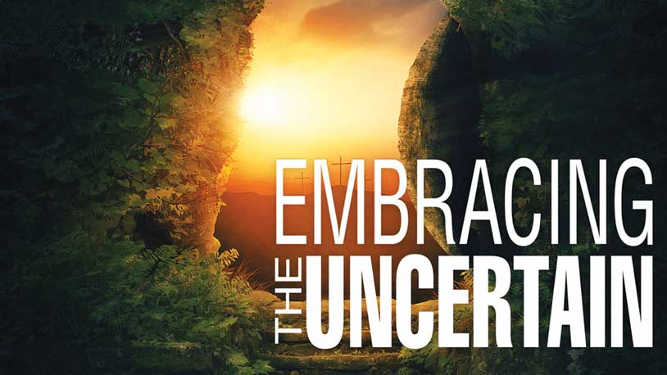

2020 Lenten Worship Series

Based on the book
Embracing the Uncertain: A Lenten Study for Unsteady Times
by Magrey R. deVega

Produced by
Corps and Community Mission Department
with
Music and Creative Arts Ministries

Editor/Project Manager
Mark Bender

Worship Outlines
Peggy Thomas

Dramas
Martyn S. Thomas

The Salvation Army | USA Central Territory
Commissioner Brad Bailey, Territorial Commander

FOREWORD

Embracing the Uncertain
2020 Lenten Worship Series

Just turning on the news shows that we live in uncertain times. Economic instabilities, eruptions of violence, and natural catastrophes can alter the lives and landscapes of entire communities. Our individual lives are often just as unsteady: relationships can break, plans can falter, and confidence can fail. Most of us find uncertainty to be uncomfortable, preferring stability and a predictable future to an unknown fate. We are wired to want to control our destiny. Embracing the Uncertain, our theme for our Lenten series, invites you to take a different perspective. Instead of ignoring or hiding from life’s uncertainties, you can engage them with confidence and find a stronger faith along the way.

In Embracing the Uncertain, we will explore six stories in the Gospels as Jesus travels toward Jerusalem, where he will be crucified. These stories are signposts in the gospel narrative, pointing down at a world filled with uncertainty, yet pointing us forward to a cross that can show us how to follow Jesus with courage, obedience, and the hope of the resurrection.

In our fast-changing, unpredictable world there are few guarantees in life. It’s those who are willing to embrace uncertainty and make the risky decision to follow Jesus despite the many unknowns who will reap the greatest rewards.

This series is based on Magrey deVega’s book: Embracing the Uncertain: A Lenten Study for Unsteady Times.

Themes for the series are as follows:

Week One (March 1, 2020): The Uncertainty of Faith
Week Two (March 8, 2020): The Uncertainty of Forgiveness
Week Three (March 15, 2020): The Uncertainty of Worry
Week Four (March 22, 2020): The Uncertainty of Mortality
Week Five (March 29, 2020): The Uncertainty of Surrender
Palm Sunday (April 5, 2020): The Uncertainty of Obedience
Good Friday (April 10, 2020): Tenebrae Service
Easter SonRise (April 12, 2020): Go See Him for Yourself!
Easter Service (April 12, 2020): The Proof of the Resurrection
Worship Outlines contain:
- Song Options
- Calls to Worship/Scripture/Responsive Readings
- Embracing the Uncertain Prayer Focuses
- Dramas
- Sample Sermons by Magrey deVega

Each worship outline contains all elements needed for your worship service. The order of each service presented is only a suggestion. No doubt changes will be needed to accommodate the flow and worship style of your corps. The outlines are flexible and allow opportunities to “cut and paste” as needed. If you are blessed with instrumental or vocal music resources, you may find there is more structured material here than needed. It is recommended that the headings of each section of the service be included in the bulletin.

APPRECIATION

In producing this series, the Corps and Community Mission Department expresses its indebtedness to Peggy Thomas and Martyn Thomas (Music and Creative Arts Ministries), and Mark Bender for their creativity, editing, and hard work. Translation into Spanish has been expertly provided through Alfredo Martinez (Intercultural Ministries Department).

DeVega, Magrey R. Embracing the Uncertain: a Lenten Study for Unsteady Times. Abingdon Press, 2017.

Unless otherwise noted, this series is © Copyright 2020, The Salvation Army, Hoffman Estates, Illinois.

Embracing the Uncertain
2020 Lenten Worship Series

CONTENTS

Week 1 – The Uncertainty of Faith (Mark 9:14-29)
- Worship Service Outline
- Drama: Bumper-to-Bumper Warranty
- Sermon: Doubt

Week 2 – The Uncertainty of Forgiveness (Matthew 18:21-35)
- Worship Service Outline
- Drama: 489 and Counting
- Sermon: Forgiveness
- Graphics: Sermon Illustrations (JPGs): Spite House

Week 3 – The Uncertainty of Worry (Luke 12:13-34)
- Worship Service Outline
- Drama: By Any Other Name
- Sermon: Worry

Week 4 – The Uncertainty of Mortality (John 11:17-37)
- Worship Service Outline
- Drama: Better Late Than Never
- Sermon: Mortality

Week 5 – The Uncertainty of Surrender (Luke 19:1-10)
- Worship Service Outline
- Drama: Climbing to the Top
- Sermon: Surrender
Palm Sunday – The Uncertainty of Obedience (Matthew 26:36-46)
- Worship Service Outline
- Drama: Wide Awake
- Sermon: Obedience

Good Friday – Tenebrae Service (Words spoken to Jesus)

Easter SonRise – Go See Him for Yourself! (Matthew, Mark and John)
- Worship Service Outline
- Drama: Empty
- Sermon: Go See Him for Yourself!

Easter Service – The Proof of the Resurrection (John 20:1-18)
- Worship Service Outline
- Drama: Mourning to Dancing
- Sermon: When God Calls You by Name

Embracing the Uncertain
2020 Lenten Worship Series
EXPLANATORY NOTES

WORSHIP SERVICE OUTLINES
Each worship outline contains all elements needed for your worship service. The order of each service presented is only a suggestion. No doubt changes will be needed to accommodate the flow and worship style of your corps. The outlines are flexible and allow opportunities to “cut and paste” as needed. To better accommodate changes, these worship service outlines are provided on the Music and Gospel Arts Website: www.samusiccentral.org under resources.

If you are blessed with instrumental or vocal music resources, you may find there is more structured material here than needed.

SONGS
Music is an essential component of any worship service. It is a signal to unite and begin. It establishes the setting for praise and meditation. It adds variety, vitality and focus to worship. It can also be a means of learning and retaining spiritual truth, as well as expressing and sharing our faith.

These worship outlines are designed with the smallest to the largest congregation in mind, allowing for live (piano, ensemble, band, etc.) and recorded (compact discs) accompaniment.

All CD accompaniment songs/choruses have been chosen from the “Hymn Tune Accompaniment (HT)” and “Hallelujah Choruses (HC)” accompaniment compact discs. Very often an optional song or chorus is given which would fit at that point in the service in place of the original choice. You may wish to sing several of these songs as an additional worship time.

The information for each service component is listed in a grid format as in the following example.

HC#179 – Come to Jesus | HC-179 | HCD16-T19
Additional Optional Songs
SB#917 – Christ for the world, we sing | TB-198 – Moscow | HTD2-T2 (4 vs.)

Accompaniment abbreviations:
SB Salvation Army Song Book – words
TB Salvation Army Tune Book – tunes
HC Hallelujah Choruses
HTD2-T2 Hymn Tune Accompaniment Disc #2, Track #2
HC-179 Hallelujah Choruses, Song #179
HCD3-T3 Hallelujah Choruses, Disc #3, Track #3

Careful attention is needed when singing songs in a medley. When planning and selecting songs it is important to understand the difference between songs about God (a horizontal perspective) and songs sung to God (a vertical perspective). There is a generally held principle that these perspectives should not shift back and forth. For instance, if you were to sing “O Worship the King” (horizontal song) and “Shout to the Lord” (vertical song) consecutively, it is more conducive to worship to sing “O Worship the King” first and then “Shout to the Lord”, rather than the reverse. Once a vertical song is sung, it needs some type of resolution, whether it be a prayer or another vertical song. Worship “moments” can lose their impact if care is not taken in this area. Also, try to avoid mixing songs with radically different tempos or styles.

Vocal benediction options have been included for each service which can be an effective way to end each service.

CALL TO WORSHIP/RESPONSIVE READING
Services usually begin with a Call to Worship which introduces the theme of the service.

A responsive reading has been included in each service. This responsive reading is often a combination of scripture and material from the book, Embracing the Uncertain.

Feel free to edit these as needed.

DRAMAS
Drama sketches have been included in the series to add variety and depth to worship. The experience of seeing the Word portrayed, in addition to hearing the Word proclaimed, can provide worshipers with increased understanding and perspective.

While it is not always necessary to memorize a script, memorization enhances any dramatic presentation when time and proficiency permit. Props are kept to a minimum. It is important to take time to read through the script before using this series to know what preparations will be needed.

SOURCE MATERIAL FOR SERMONS
Source material for the sermons are provided as a guide in preparation for a total worship experience. Each sermon included should be viewed as a catalyst for preaching, not a verbatim reading. These will be most effective if they are adapted, using personalized illustrations that relate to your specific congregation. Original illustrations have been left in but should only be used as a guideline.

SUPPORT RESOURCES NEEDED FOR THIS SERIES
Keyboard/Instrumental Accompaniment
The Salvation Army Song Book (2015) – vocal
The Salvation Army Tune Books (2015) – piano/band
Hallelujah Choruses Songbooks 1-25
Hallelujah Choruses Instrumental Series 1-25 or
Hallelujah Choruses Piano/Rhythm Book (Nos. 1-100, 101-200, 201-250)

OR:

CD Accompaniment
Hymn Tune Accompaniments compact discs (12 total)
Hallelujah Choruses accompaniment compact discs 1-25

Bibliography
DeVega, Magrey R. Embracing the Uncertain: a Lenten Study for Unsteady Times. Abingdon Press, 2017.

Maranatha! The NIV Worship Bible. Grand Rapids: Zondervan, 2000.

SCRIPTURE VERSIONS
(CEB) Scripture quotations unless noted otherwise are taken from the Common English Bible, copyright 2011. Used by permission. All rights reserved.

(NASB) Scripture taken from the NEW AMERICAN STANDARD BIBLE®, Copyright © 1960,1962,1963,1968,1971,1972,1973,1975,1977,1995 by The Lockman Foundation. Used by permission.

(NIV) THE HOLY BIBLE, NEW INTERNATIONAL VERSION®, NIV® Copyright © 1973, 1978, 1984, 2011 by Biblica, Inc.® Used by permission. All rights reserved worldwide.

(NRSV) Scripture quotations are from the New Revised Standard Version Bible, copyright © 1989 the Division of Christian Education of the National Council of the Churches of Christ in the United States of America. Used by permission. All rights reserved.

(VOICE) Scripture taken from The VoiceTM. Copyright © 2008 by Ecclesia Bible Society. Used by permission. All rights reserved.

